Title: Register for a Super Speaker
Super Speaker Saturday is October 24th. This is your opportunity to hear from RIT alumni about their journey after RIT. Please use the CampusGroups event pages and find out more about each speaker and register to attend at least one of the speakers or both if you are interested.
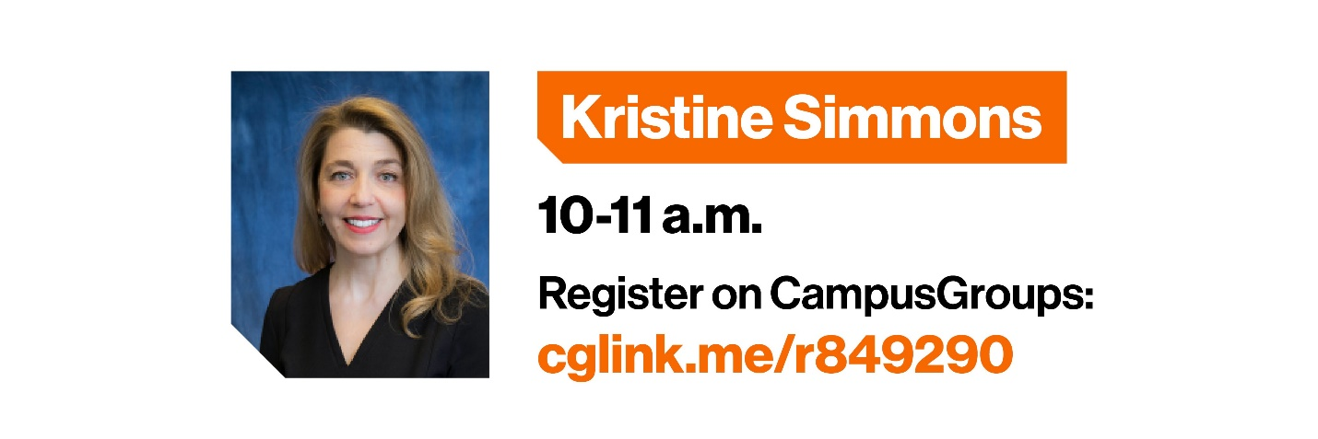
CampusGroups Event Link for Kristine Simmons
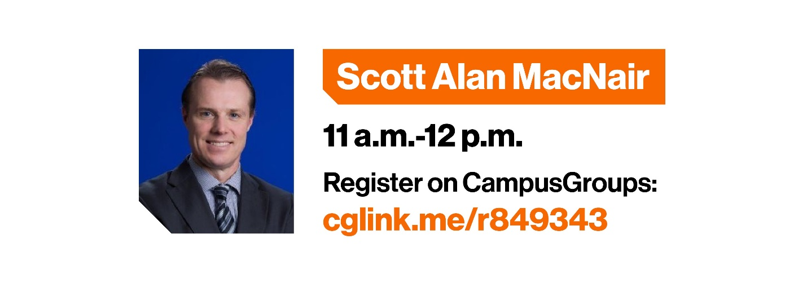
CampusGroups Event Link for Scott Alan MacNair

